  HUMN OCCUPATIONAL & TECHNICAL SAFETY ASSESSMENT PLATFORM  Capstone Professional Project  Final Report  Date: 30/10/2025 | Group 2025-SP5-107  Shylyn Paliza Garcia Garsy036  Hoang Chau Nguyen Nguhy158  Thi Thu Trang Nguyen Nguty440

Table of Contents
Executive Summary 4
1. Introduction 5
1.1 Background and Context 5
1.2 Problem Statement and Initial Needs 6
1.3 Project Scope 9
1.3.1 In Scope 9
1.3.2 Out of Scope 10
1.4 Project Objectives 10
1.5 Stakeholders and Roles 11
1.6 Final Deliverables 12
1.7 Organisational Benefit 13
2. Literature Review 14
2.1 Digital Transformation and Compliance 14
2.2 Automation in Workplaces 15
2.3 Low-Code and No-Code Development Platforms 16
2.4 Summary of Trends 17
3. Methodology 18
3.1 Rationale for Methodologies 18
3.2 Application of Methodologies 19
4. Project Implementation 21
4.1 Project Approach 21
4.1.1 Planning 21
4.1.2 Research 24
4.1.3 Task Allocation 25
4.2 Discussion 25
4.2.1 Prototype v1 - First Working Forms and Manual Logic 26
4.2.2 Prototype v2 – Dataverse Integration and Conditional Logic 27
4.2.3 Prototype v3 – MVP Dashboard Mock, Login, Readiness Survey + Automation 29
4.2.4 Final MVP – Integrated Submission, Validation, and Secure Storage 30
4.2.5 Testing, Client Engagement, and What Improved Over Time 31
5. Outcomes & Future Recommendations 31
5.1 Summary of Final Outcomes 31
5.2 Achievement of Organisational Benefits 32
5.2.1 Business Impacts 32
5.2.2 Client Impacts 33
5.3 Limitations of Current Prototype 33
5.4 Recommendations for Future Development 34
5.5 Scalability and Long-Term Adoption Considerations 35
6. Reflection 35
6.1 Evaluation of Methodology and Approach 35
6.2 Key Challenges and Obstacles 36
6.3 Lessons Learned 36
6.4 Personal Reflection on Skills Developed 37
7. Conclusion 37
8. References 40

Figure 1: AS-IS Workflow of Humn’s Certification Process 5
Figure 2: TO-BE Workflow of Humn’s Certification Process 7
Figure 3: The Double Diamond model adapted from the Design Council (2025). 18
Figure 4: Project Schedule 21
Figure 5: HUMN Consultant Persona – Review/Auditor of Submissions 22
Figure 6: HR Manager Persona – Primary decision-maker for Psychosocial Compliance 22
Figure 7: PsychSafe Navigator Form interface for desktop and mobile versions 24
Figure 8: Data flows in Dataverse 25
Figure 9: Dropdown function for Hazard Category 26
Figure 10: Auto-calculation for Inherent Risk Score based on Consequence x Likelihood 26
Figure 11: Login Screen for users portal 27
Figure 12: Automated PsychSafe Result & Recommendation Email Workflow 28

Table 1: Integration of Double Diamond and Agile 19

Executive Summary
The Humn Occupational and Technical Safety Assessment (HOTSA) project was developed in collaboration with Humn Pty Ltd, a South Australian organisation specialising in psychosocial safety certification aligned with ISO 45003:2021 and the Work Health and Safety Act 2012 (SA). The project addressed the limitations of Humn’s manual, Excel-based risk assessment system, which was time-consuming, error-prone, and lacked compliance visibility.
The objective was to design a secure, low-code prototype that automates psychosocial risk assessments and reporting through the Microsoft Power Platform. The prototype integrates Power Apps, Dataverse, Power Automate, and Power BI to replace manual data entry and reporting with automated workflows. The scope focused on delivering key modules — the PsychSafe Navigator Readiness Survey, the Team-Based Risk Assessment (TBRA) worksheet, and automated email and data synchronisation flows — within a 13-week development timeline.
The project applied a hybrid methodology combining Design Thinking (the Double Diamond framework) and Agile sprints. This approach enabled user-centred design, iterative development, and refinement based on continuous client feedback. It ensured that the solution remained practical, compliant, and achievable within both academic and organisational constraints.
The final deliverables include the redesigned AS-IS/TO-BE workflows, a functional TBRA worksheet prototype, automated readiness email workflows, and dashboard mock-ups demonstrating future reporting potential. These outputs collectively enhance operational efficiency, data integrity, and compliance alignment with ISO 45003 and ISO/IEC 27001 standards.
The project demonstrated tangible improvements in process efficiency, data security, and user experience. Our automated solution reduces manual processing by approximately 40–50%, eliminated human error from validation logic, and enabled secure audit-ready data management through Dataverse. While some advanced analytics were deferred due to time constraints, the prototype established a strong foundation for Humn’s future digital transformation roadmap — positioning the organisation to scale toward a fully integrated CRM and compliance management platform.

1. Introduction

1.1 Background and Context
Humn Pty Ltd, headquartered in South Australia, is an organisation specialising in workplace psychosocial safety certification aligned with ISO 45003:2021 and the Work Health and Safety Act 2012 (SA). The company’s mission is to help organisations build mentally healthy workplaces by identifying and managing psychosocial hazards that affect employee well-being and organisational performance. Humn’s clients include private enterprises, public agencies, and not-for-profit organisations, with Human Resources (HR) and Work Health and Safety (WHS) teams serving as the primary end users. In the longer term, Humn plans to expand its certification services to other key stakeholders such as SafeWork SA, Return to Work SA, Comcare, and insurance providers.
Before this project commenced, Humn’s certification process for psychosocial safety assessments relied heavily on manual Excel spreadsheets and email exchanges. Staff members distributed surveys to clients, entered responses into Excel, and used formulas to calculate risk ratings and residual hazard levels. Reports were then compiled and sent back to clients via email.
While functional, this process was increasingly inefficient and error-prone as client numbers grew. The absence of automation and integration made data handling inconsistent, and report generation time-consuming. Furthermore, the lack of a unified data repository created challenges in data tracking and auditability, which are essential for ISO 45003 and WHS Act compliance.
Recognising these challenges, the organisation partnered with the project team to explore digital transformation opportunities. The goal was to modernise the certification workflow through a low-code prototype built using Microsoft Power Platform (Power Apps, Dataverse, Power Automate, and Power BI). This approach was intended to replace the manual Excel system with a secure, scalable, and efficient platform that would streamline psychosocial risk assessment and reporting.

1.2 Problem Statement and Initial Needs
The following section outlines the current problems within Humn’s certification process and the resulting needs that led to the development of the HOTSA digital prototype.
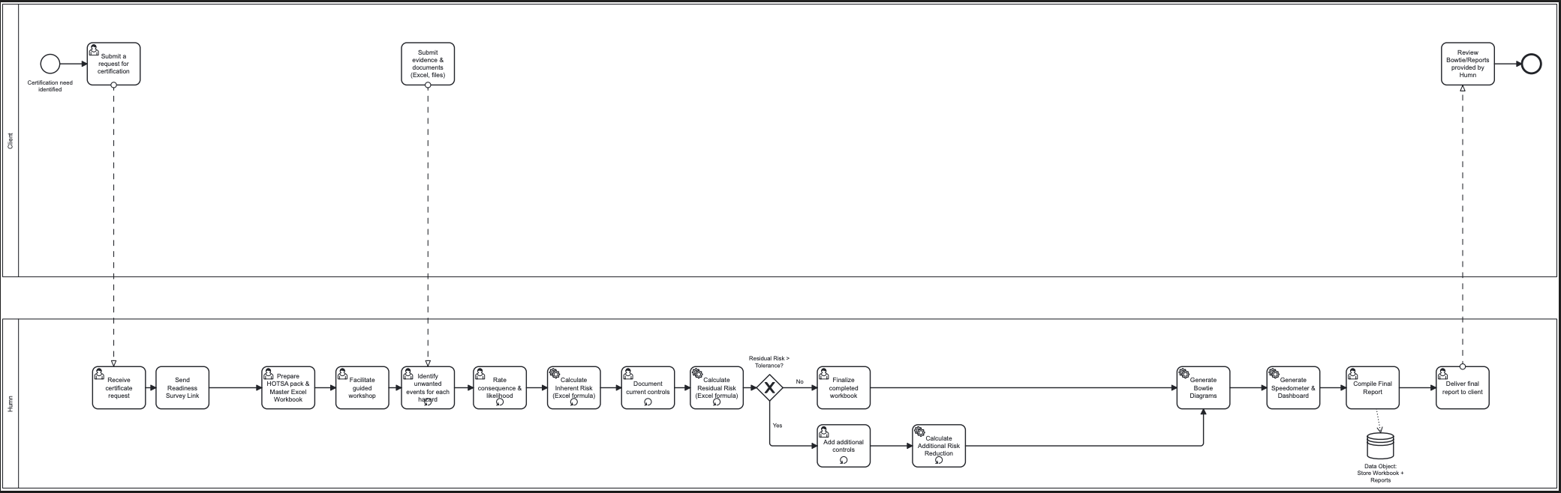
Figure 1: AS-IS Workflow of Humn’s Certification Process
The diagram illustrates Humn’s existing certification workflow, which relies entirely on manual Excel workbooks and email communication between the client and Humn staff. The process begins when the client identifies a certification need and submits a request to Humn. The team then sends a readiness survey link and prepares the HOTSA assessment pack in Excel format. Each hazard is manually rated for consequence and likelihood, and formulas are used to calculate inherent and residual risk scores. If the residual risk exceeds the tolerance threshold, additional controls are added and recalculated until acceptable levels are reached. Once the assessment is
completed, Humn staff compile the final workbook, generate Bowtie diagrams and dashboards, and deliver the final report to the client via email. This manual approach is time-consuming, prone to human error, and lacks version control and real-time visibility across the assessment lifecycle.
The project team identified several key issues through process mapping and discussions with the client:
- High error and data loss risk: Without version control or automated validation, spreadsheets often contained duplicate or overwritten entries, compromising the reliability of assessment data.
- Limited scalability: The manual workflow required significant staff time to manage each certification case, making it difficult to handle larger client volumes.
- Time inefficiency: Manual calculations and report generation not only delayed feedback cycles and reduced client responsiveness, but also increased staff workload, extended turnaround times, and ultimately resulted in higher operational costs for the business.
- Lack of data visualisation: There was no consolidated dashboard to monitor psychosocial hazards, risk scores, or certification progress in real time.
- Data security concerns: Exchanging confidential evidence through email increased privacy and compliance risks, particularly regarding ISO/IEC 27001:2013 and the Australian Privacy Principles (APPs).
These limitations collectively impacted the organisation’s ability to maintain efficiency, ensure compliance, and deliver timely certification outcomes. Consequently, a strong need emerged for a secure, automated, and centralised system that could eliminate manual errors, provide real-time analytics, and streamline the certification process end-to-end.
The team therefore proposed developing a prototype digital platform using Microsoft Power Platform technologies. This solution aimed to automate risk scoring, centralise data management within Dataverse, and enable visual reporting through Power BI dashboards. It also aligned with the regulatory standards outlined in ISO 45003:2021 and
the WHS Act 2012 (SA), ensuring that compliance and usability remained at the core of the new system’s design.
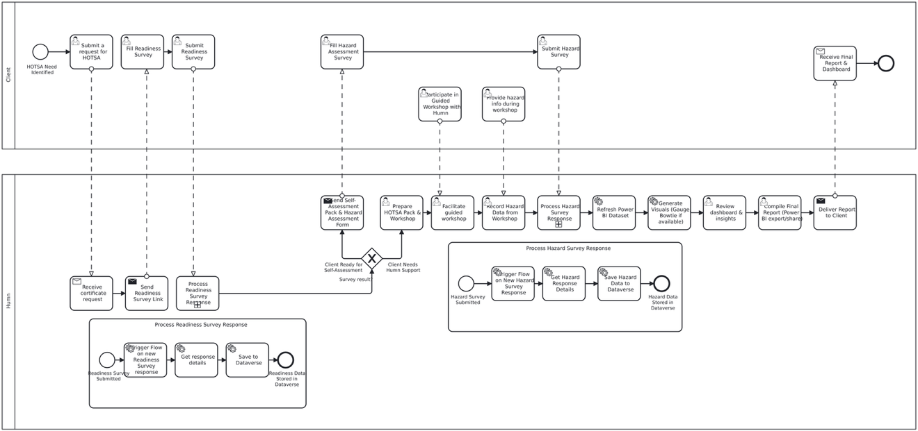
Figure 2: TO-BE Workflow of Humn’s Certification Process
The redesigned TO-BE workflow demonstrates how the proposed digital platform automates the certification process, replacing manual Excel operations with integrated Power Platform components and improving data accuracy, efficiency, and compliance visibility.

1.3 Project Scope
The HOTSA project was designed to deliver a secure, low-code digital prototype that automates Humn’s psychosocial safety certification process. The scope focused on transforming the existing manual Excel-based workflow into an integrated platform using Microsoft Power Platform tools — Power Apps, Power Automate, Dataverse, and Power BI.
This defined boundary ensured that the project remained feasible within the 13-week timeframe while addressing the organisation’s most critical operational and compliance needs.
Within this scope, the project team conducted research and feasibility analysis, mapped digital workflows, and developed automated survey forms to capture readiness and hazard data securely.
To ensure the solution’s practicality and alignment with Humn’s business objectives, specific inclusions and exclusions were established as follows:

1.3.1 In Scope
The project includes the following key activities and deliverables:
- Review and analyse the current evidence submission process, materials, and formats.
- Map and design digital workflows aligned with the certification process.
- Design and prototype a secure digital form and portal using Microsoft Power Apps.
- Incorporate hazard identification and conditional logic capabilities into the solution.
- Enable automation features such as notifications, reminders, and timestamping through Power Automate.
- Integrate secure document upload and backend connectivity options via Dataverse.
- Ensure compliance with ISO 45003:2021, ISO/IEC 27001:2013, and the Australian Privacy Principles (APPs) to support data security, privacy, and regulatory alignment.
- Create comprehensive user and administrator documentation, including guides and quick reference materials.
- Conduct internal testing sessions and capture feedback for iterative improvement.
- Demonstrate and hand over the final deliverables to the Humn team.

1.3.2 Out of Scope
To maintain a realistic project boundary, the following elements were excluded from the project:
- Full computer or mobile application development beyond the prototype.
- Advanced Artificial Intelligence (AI), Natural Language Processing (NLP), or Machine Learning capabilities.
- Integration with external enterprise systems or third-party services.
- Legal validation or audit of uploaded documents or files.
- Ongoing maintenance or post-handover technical support.
- The defined scope ensured that the project achieved its primary goal of demonstrating a functional, automated certification workflow while laying a scalable foundation for Humn’s future digital transformation.

1.4 Project Objectives
The following objectives provided a structured foundation for achieving a secure, user-friendly, and compliant prototype that demonstrates Humn’s readiness for digital transformation:
- Conduct research and feasibility studies to identify the most suitable low-code tools for digital transformation.
- Apply best practice project management methodologies, combining Design Thinking approaches (Double Diamond) and Agile to guide development.
- Design user interface (UI) and user experience (UX) layouts, process maps, and data flows to optimise usability and data traceability.
- Replace Excel-based tools with a Power Apps digital portal supporting hazard entry, automated risk assessment, and control tracking.
- Implement validation logic, pre-filled fields, and progress tracking within the evidence submission workflow to improve accuracy and user experience.
- Develop comprehensive training materials, user guides, and Standard Operating Procedures (SOPs) to support knowledge transfer and client adoption after handover.

1.5 Stakeholders and Roles
The HOTSA project involved the following internal and external stakeholders who played critical roles in ensuring the project’s successful delivery:
- Kristen Raison – Chief Executive Officer, Humn (Client Sponsor)
- Provided strategic direction and ensured project alignment with Humn’s organisational goals. Approved key deliverables and scope changes, and facilitated access to organisational resources and relevant staff.
- Sam Young – Chief Health Officer, Humn (Health Compliance Advisor)
- Advised on psychosocial risk assessment compliance and alignment with the Model WHS Act and ISO 45003:2021. Offered subject-matter expertise on workplace well-being and psychosocial hazard management.
- Martyn Campbell – Health & Safety Professional, Humn (Safety Standards Advisor)
- Contributed expert input on safety standards and reviewed the platform design to ensure compliance with health and safety frameworks.
- Toby Rady – Project Supervisor (Academic Mentor), UniSA
- Provided academic guidance and technical supervision throughout the project lifecycle. Reviewed draft deliverables, ensured methodological rigour, and supported alignment with academic requirements.
- Hoang Chau Nguyen – Project Manager, UniSA Student Team
- Oversaw the overall execution of the project, including scope management, quality control, and stakeholder engagement. Led sprint planning and monitored progress to ensure timely delivery.
- Shylyn Paliza Garcia – Business Analyst & Engagement Coordinator, UniSA Student Team
- Captured client requirements and translated them into functional specifications. Coordinated client communication, managed meeting schedules, and documented feedback to support iterative development.
- Thi Thu Trang Nguyen – Project & Resource Coordinator, UniSA Student Team
- Managed resource allocation, tools, and platform access to meet project milestones. Coordinated internal tasks, resolved resource constraints, and supported automation testing and workflow validation.

1.6 Final Deliverables
The team developed the following deliverables, using Microsoft Power Platform, with the aim of improving efficiency, accuracy, and compliance while providing a scalable foundation for future digital maturity:
- AS-IS and TO-BE Workflow Diagrams
Visualise the transition from the existing manual certification process to the redesigned automated system. These diagrams serve as the blueprint for digital transformation, highlighting process inefficiencies and illustrating streamlined data flows across the certification lifecycle.
- PsychSafe Navigator – Readiness Survey Form
A responsive digital form accessible via desktop and mobile devices that enables organisations to assess their psychosocial safety maturity. The survey collects responses to 18 structured questions and provides instant readiness classification with tailored improvement recommendations.
- Power Automate Workflows
Two automated workflows were developed:
- Data Sync to Dataverse – Automatically transfers form responses into Microsoft Dataverse for secure storage and real-time reporting.
- Automated Result and Recommendation Email – Instantly sends personalised feedback and psychosocial safety recommendations to participants upon form submission.
- TBRA Worksheet Prototype
The TBRA worksheet prototype was built in Microsoft Power Apps with Dataverse, replacing manual Excel assessments. It includes automated risk scoring, conditional branching, and dependent dropdowns (e.g., Hazard Category → Unwanted Event) to reduce errors and ensure consistent, traceable calculations. Users can collaboratively assess psychosocial hazards, apply controls, and view updated residual risk levels, improving accuracy and transparency over spreadsheet methods.
- Reporting Dashboards and Mock-ups
A static reporting dashboard mock-up in Power Apps demonstrates real-time visibility into assessment submissions and risk alerts, including recent submissions, attention-needed items, and category-level indicators. Though Power BI analytics were deferred, this interface outlines future data visualisation for compliance monitoring and client reporting under ISO 45003.
These deliverables improve operational efficiency, data integrity, and compliance while providing a scalable foundation for Humn's digital transformation.

1.7 Organisational Benefit
The HOTSA prototype demonstrated the potential for significant organisational benefits for Humn Pty Ltd, both in operational efficiency and compliance management, such as:
- Reduced processing time: The automation of survey submission, data validation, and report generation reduced certification turnaround times by approximately 40–50%. Tasks that previously required multiple manual steps were completed within minutes through Power Automate flows.
- Minimised manual entry errors: The use of validation logic, pre-filled fields, and structured Dataverse schemas minimised human input errors and improved the reliability of risk calculations.
- Centralised data management: Dataverse enabled secure, real-time data storage and retrieval, eliminating version conflicts and ensuring traceability throughout the certification lifecycle.
- Streamlined reporting: Power BI dashboards provided immediate visualisation of hazard categories, residual risk ratings, and progress indicators, reducing time spent on manual chart creation.
- Compliance with ISO and WHS standards: The prototype aligned with ISO 45003:2021, ISO/IEC 27001:2013, and the Work Health and Safety Act 2012 (SA), demonstrating that psychosocial safety assessments can be securely managed in a low-code environment.
- Enhanced client experience: The intuitive user interface and transparent digital workflow improved client engagement, allowing users to track progress and receive real-time feedback throughout the certification process.

2. Literature Review

2.1 Digital Transformation and Compliance
Digital transformation has evolved from being a purely technological shift to a strategic enabler of compliance, governance, and organisational resilience. Hinterhuber, Vescovi, and Checchinato (2024) describe digital transformation as a multidisciplinary process that fundamentally changes how organisations deliver value through data, connectivity, and automation. They argue that the challenge is not whether to transform but how to implement transformation strategies that align with ethical, legal, and compliance obligations. The authors emphasise that the majority of organisations struggle with governance and readiness for digital change, underlining the need for frameworks that integrate compliance from the outset.
Similarly, Graf, Weiß, and Schünemann (2025) highlight that as workplaces become increasingly digitalised, compliance must extend beyond technical security to include psychosocial safety and human well-being. Their research on digital psychosocial risk assessment demonstrates that automation and digital tools can both improve and complicate compliance. When used appropriately, digital platforms enhance transparency, traceability, and auditability; however, they also introduce new risks such as data overload and privacy vulnerabilities. Effective digital transformation therefore requires a dual focus — adopting innovation while maintaining adherence to ethical and regulatory standards.
From a standards perspective, the ISO/IEC 27001:2022 framework provides the foundation for information security management by outlining requirements for protecting data confidentiality, integrity, and availability (International Organization for Standardization & International Electrotechnical Commission, 2022). It ensures that digital systems have defined controls for risk assessment, access management, and incident response. Complementing this, ISO 45003:2021 focuses on psychosocial health and safety, guiding organisations to identify and manage risks related to employee mental well-being (International Organization for Standardization, 2021). The alignment of these two standards ensures that digital systems protect both information and people — a critical balance in compliance-driven transformation.
Overall, literature and practice converge on a shared conclusion: compliance is not a constraint but a core pillar of sustainable digital transformation. When compliance is embedded into digital architecture, it strengthens organisational trust, protects user data, and ensures that innovation contributes positively to human and societal well-being — principles central to the HOTSA platform’s design and implementation.

2.2 Automation in Workplaces
Automation has become a defining component of digital transformation, reshaping how organisations design workflows, enhance accuracy, and improve productivity. Davenport and Kirby (2023) emphasise that automation provides the greatest value when it complements, rather than replaces, human expertise. They argue that effective automation enhances reliability, compliance, and decision quality across business processes, enabling people to focus on high-value tasks. This perspective reinforces the idea that digital transformation succeeds not only through technology but also through human-centred governance and collaboration.
Similarly, Bolton, Machová, Kovacova, and Valaskova (2018) highlight that artificial intelligence (AI) and automation increase efficiency while expanding human capability. They explain that automation can handle repetitive and data-intensive work, allowing employees to concentrate on complex decision-making and skill development. The authors further note that automation should not merely be viewed as a tool for cost reduction but as a system for empowering people and promoting innovation through human–machine collaboration.
From a technical standpoint, Microsoft (2023) defines Power Automate as a low-code workflow platform that enables users to automate repetitive business processes without extensive programming knowledge. The platform supports event-driven, scheduled, and instant workflows, connecting people, data, and applications across the organisation. Microsoft also outlines built-in governance features such as audit logging, data loss prevention, and environment-level management that help ensure security and compliance. These features make Power Automate a practical tool for integrating automation into day-to-day business operations while maintaining transparency and accountability.
In summary, academic and industry research converge on the idea that automation—when guided by human-centred principles—enhances efficiency, accuracy, and compliance while preserving employee engagement. The HOTSA project embodies this approach by using Power Automate to streamline risk assessment workflows, reduce administrative effort, and strengthen governance and psychosocial safety outcomes.

2.3 Low-Code and No-Code Development Platforms
Low-code and no-code (LCNC) platforms have emerged as key enablers of digital transformation, allowing both professional developers and non-technical users to build applications rapidly with minimal programming knowledge. Guthardt, Kosiol, and Hohlfeld (2024) empirically demonstrated that citizen developers can achieve performance levels comparable to professional programmers when using no-code builders. Their study found “no significant difference in task correctness or processing time between the two groups,” suggesting that LCNC tools can effectively democratise software development. This capability is particularly valuable for small and medium-sized enterprises (SMEs) that often face limited IT resources and need agile digital solutions.
Industry research reinforces this academic perspective. The Forrester Wave report (Bratincevic & Koplowitz, 2021) identified low-code platforms as a “first-class development approach,” recommending that enterprises adopt them for data-driven and process-centric workflows. Microsoft Power Apps was highlighted as a standardized low-code platform of choice due to its robust integration ecosystem and connector framework that supports automation and analytics. Similarly, Gartner’s (2023) Magic Quadrant for Enterprise Low-Code Application Platforms defined LCAPs as frameworks that “rapidly develop and deploy custom applications by abstracting and minimizing or replacing the coding needed in development” (NewsRX Staff, 2023, p. 293). The report emphasised that mature LCNC platforms must support workflows, data services, and governance capabilities to ensure security and scalability.
These findings collectively position low-code solutions as strategic tools for both innovation and compliance. In the context of the HOTSA project, adopting Microsoft Power Platform aligns with this global shift. Power Apps and Dataverse enable Humn to replace manual Excel workflows with a secure, integrated system that supports automated data capture, validation logic, and dashboard generation. The low-code model not only accelerates development but also empowers non-technical staff—such as WHS and HR teams—to modify and extend forms without depending on external developers. This directly supports the project’s goal of sustainable digital transformation and aligns with ISO 45003 and ISO/IEC 27001 compliance principles.
In summary, literature and industry evidence confirm that low-code development is both technically feasible and strategically advantageous for organisations seeking digital transformation under constrained resources. It provides the foundation upon which workflow automation and compliance capabilities—discussed in the following section—are built.

2.4 Summary of Trends
The transition from traditional spreadsheet-based workflows to low-code and automation-driven systems marks not only a technological upgrade but a fundamental rethinking of how compliance, efficiency, and employee well-being are integrated into organisational processes.
Low-code platforms enable faster solution development and greater accessibility for non-technical users (Guthardt et al., 2024; Microsoft, 2023), while automation reduces manual workload and human error, enhancing process reliability (Davenport & Kirby, 2023; Bolton et al., 2018). Together, these technologies create a foundation for compliance-by-design — embedding governance, data protection, and traceability within digital systems (ISO, 2021; ISO/IEC, 2022).
This convergence of Low-code Development, Automation, and Compliance Frameworks represents a major trend in digital transformation. Organisations adopting such systems not only achieve operational efficiency but also strengthen information security and psychosocial safety, aligning with the objectives of the HOTSA platform.

3. Methodology

3.1 Rationale for Methodologies
The methodological framework adopted for the HOTSA project — combining Design Thinking, Double Diamond, and Agile — was proposed and formally approved in the initial Project Plan on 16 August 2025 by the mentor and client representatives. This integrated approach was selected to ensure the project remained user-centred, iterative, and adaptive to stakeholder feedback within the 13-week academic timeframe.
Design Thinking was chosen as the overarching philosophy guiding the project. According to Brown (2009) and Carlgren, Rauth, and Elmquist (2016), Design Thinking promotes empathy, experimentation, and user-centric innovation. These principles aligned closely with the project’s goal of improving Humn’s psychosocial safety certification process by addressing real client pain points. The approach encouraged the team to engage directly with Humn’s staff to understand their challenges, co-create solutions, and ensure that the final deliverables addressed functional and emotional user needs. As Norman (2002) and Stickdorn et al. (2018) further emphasise, human-centred design thinking ensures that technological solutions remain intuitive, accessible, and meaningful for end users.
Building on this mindset, the Double Diamond model provided a structured framework to move from problem exploration to solution implementation. As outlined by the Design Council (2025), the four phases — Discover, Define, Develop, and Deliver — enable teams to diverge and converge thinking systematically. The team used this model to transition from understanding the existing manual process, defining a problem solution, to exploring potential solutions and developing a digital prototype. The Double Diamond framework enabled continuous validation of ideas and refinement of the problem and solution spaces toward developing a minimum viable product (MVP), whilst being aligned to client expectations.
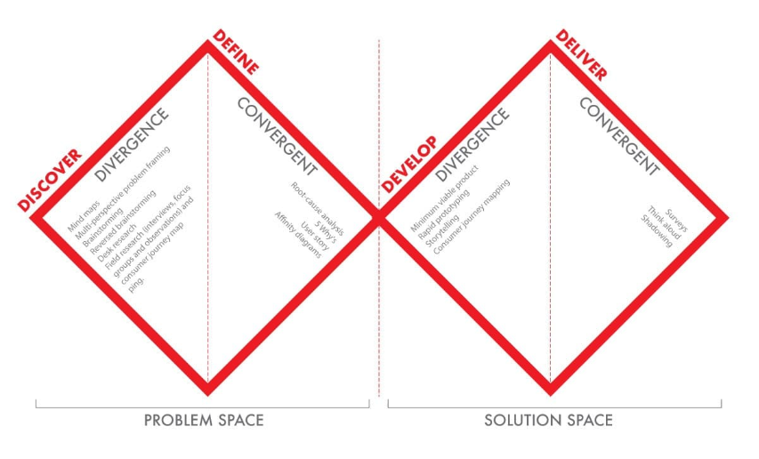
Figure 3: The Double Diamond model adapted from the Design Council (2025).
The Agile approach was adopted to manage project delivery through short, feedback-driven iterations. As noted by Serrador and Pinto (2015) and the Project Management Institute (2017), Agile is particularly effective in dynamic environments where requirements evolve throughout development. Weekly sprints were structured around key milestones — including prototype testing, stakeholder feedback, and feature refinement — allowing rapid adaptation without compromising quality. This method also promoted collaborative ownership among team members, as highlighted by Chow and Cao (2008), and facilitated transparent communication with the client and mentor.
Overall, the combination of Design Thinking, Double Diamond, and Agile created a balanced methodology — creative in discovery, structured in design, and flexible in execution. This hybrid framework ensured that the HOTSA project remained responsive to user needs, compliant with time and scope constraints, and capable of delivering a validated digital solution aligned with ISO 45003 and ISO/IEC 27001 principles.

3.2 Application of Methodologies
In the Discover phase, user research and stakeholder engagement techniques were applied to understand Humn’s certification workflow and identify inefficiencies. This approach reflected the empathy-driven mindset of Design Thinking (Brown, 2009; Carlgren et al., 2016).
The Define phase transformed insights into structured requirements and clarified the project’s scope and MVP design. Convergent thinking guided prioritisation and alignment between user needs, business goals, and technical feasibility.
The Develop phase operationalised iterative prototyping using Microsoft Power Apps and Dataverse. Feedback loops within each sprint enabled quick adjustments, demonstrating Agile’s responsiveness and collaboration focus (Chow & Cao, 2008).
Finally, the Deliver phase focused on validation and refinement through testing, automation, and user feedback. This ensured the final prototype aligned with ISO 45003 compliance and delivered measurable process improvements.
Table 1 summarises how each phase was applied in practice through Agile sprints and associated outputs.
Table 1: Integration of Double Diamond and Agile
Phase | Purpose and Focus | Agile Integration | Key Outcomes
Discover | Applied user research to analyse AS-IS workflows and psychosocial safety needs. | Sprint 1 – Research and stakeholder mapping. | Identified pain points and established project direction.
Define | Translated insights into structured requirements and MVP boundaries. | Sprint 2 – Requirements and workflow design. | Validated To-Be workflow and MVP/ scope.
Develop | Built and iteratively refined Power Apps prototype and automation flows. | Sprints 3–5 – Prototype build and testing. | Developed working MVP with conditional logic and Dataverse integration.
Deliver | Conducted usability testing and refined automation; prepared documentation. | Sprint 6 – Final testing and handover. | Completed MVP demonstration and feedback collection.
Throughout these phases, the Double Diamond enabled structured exploration and clarity, while Agile reinforced adaptability and collaboration. Together, these frameworks ensured a user-centred, iterative, and practical approach to digital solution development (Serrador & Pinto, 2015).

4. Project Implementation

4.1 Project Approach

4.1.1 Planning
The Discover phase (Weeks 1-2) focused on understanding Humn Pty Ltd’s current certification workflow, which relied heavily on static Excel spreadsheets and manual email submissions. These methods were prone to data loss, limited scalability, and lacked visibility into risk tracking. During this phase, the team reviewed relevant legislative and regulatory frameworks – including the Work Health and Safety Act 2012 (SA) and ISO 45003:2021 – to contextualise the problem. Research was also undertaken on low-code platforms and their potential to support automation and compliance. The team conducted virtual meetings with Humn’s representatives, including the Chief Executive Officer and Health Compliance Advisor, to identify pain points and clarify functional needs.
The Define phase (Weeks 3-4) was dedicated to synthesising insights into actionable requirements. The team developed As-Is and To-Be BPMN (Business Process Model and Notation) diagrams to visualise existing manual steps and proposed digital workflows. Requirements were mapped in a Requirements Mapping Document, categorising them into functional (e.g., conditional logic, file upload) and non-functional (e.g., security, accessibility) needs. By the end of this phase, the project’s MVP requirements were clearly defined: to develop a Power Apps-based platform featuring a Readiness Survey and TBRA (Team-Based Risk Assessment) worksheet, supported by Dataverse for backend data management. The client and mentor validated this direction, confirming alignment with both the WHS and ISO compliance requirements.
The Develop phase (Weeks 5-8) involved active system prototyping, testing, and refinement. Using Microsoft Power Apps and Dataverse, the team built the foundational structure for the Readiness Survey and TRBA worksheet, integrating preliminary risk-scoring logic and data validation rules. The modular approach enabled flexibility, allowing the team to introduce conditional question flows and risk factor weighting progressively. Weekly Agile sprints included sprint planning, mid-week check-ins, and sprint reviews to ensure consistent progress. Feedback from the academic mentor was incorporated to improve user interface simplicity and navigation flow.
Finally, the Deliver phase (Weeks 9-13) centred on testing, documentation, and client demonstration. Iterations during this phase addressed form usability, error-handling, and backend consistency. Limited dashboard functionality was developed as part of the MVP, although time constraints prevented full integration of visual analytics. The project concluded with an internal demonstration, preparation of user guides, and final presentation to the client and mentor. Despite some unfinished features, the final MVP successfully demonstrated automated risk scoring, conditional logic, and secure data submission - marking a significant improvement from Humn’s original manual process.
Overall, the phased structure ensured traceability between planning and execution. Each stage contributed to an evidence-based, user-driven outcome aligned with the project’s stated objectives and evaluation criteria.

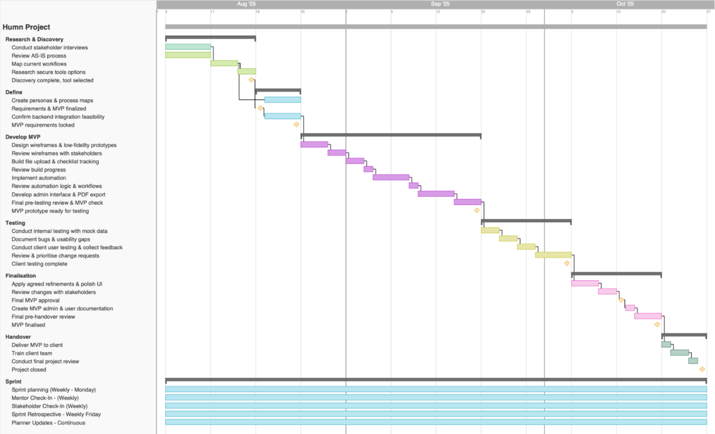
Figure 4: Project Schedule

4.1.2 Research
To keep the MVP tightly aligned with real usage, the team framed design and testing around two lightweight personas.
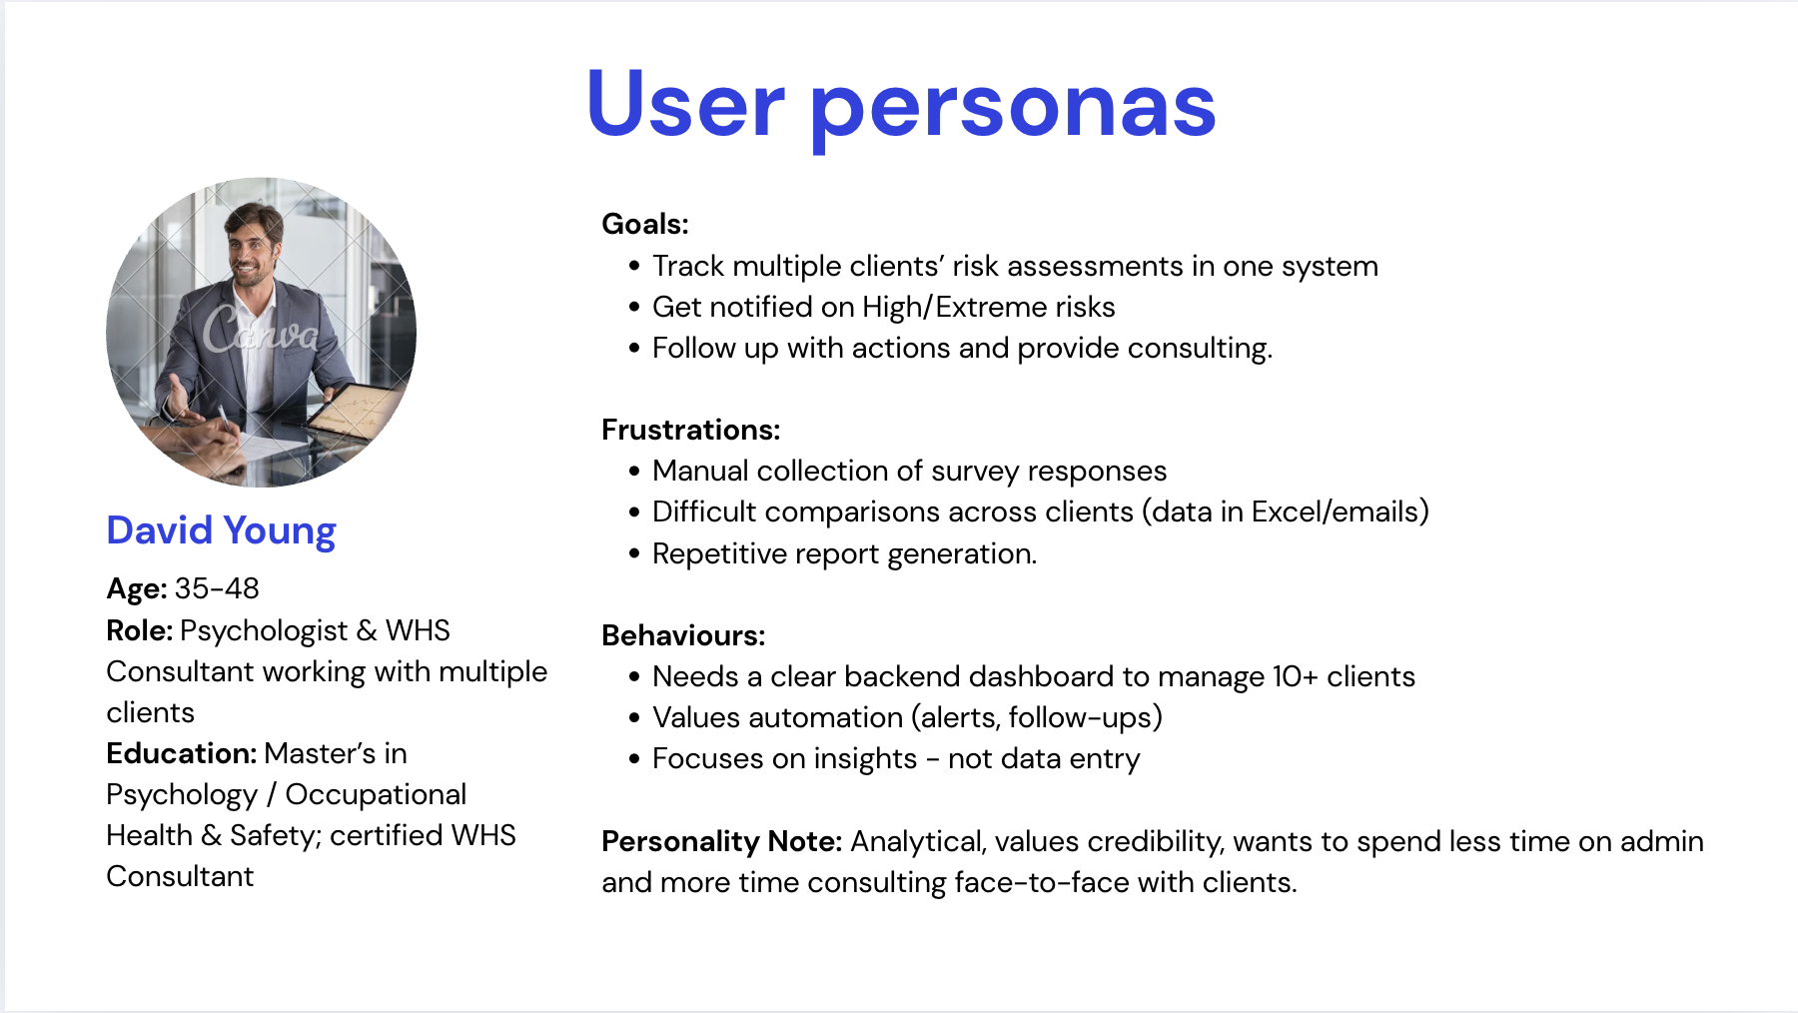
Figure 5: HUMN Consultant Persona – Review/Auditor of Submissions
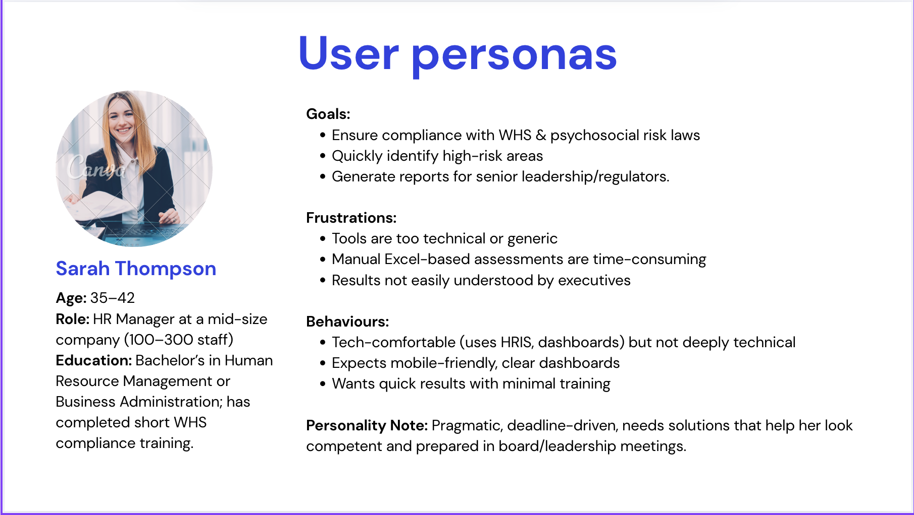
Figure 6: HR Manager Persona – Primary decision-maker for Psychosocial Compliance
It captures goals, frustrations, behaviours of each persona. The above understanding had a direct influence on the wording of the Readiness Survey, the screen length, the validation messages, and the conditional logic of only displaying what is relevant in the TBRA worksheet. The success indicators double as practical acceptance criteria (e.g., a reduced number of email back and forths, validated submissions, more understandable status), which assists the team to prioritize features as well as assess usability during the sprint scope review

4.1.3 Task Allocation
The total project effort was estimated at 20 hours per student per week for 13 weeks, amounting to approximately 260 hours per team member. This estimation, outlined in the original budget section, proved realistic in practice and was distributed across research, prototyping, testing, and documentation tasks.
The project was executed by a three-member interdisciplinary team, with clearly defined roles and collaborative overlaps to ensure continuity and shared learning. The division of responsibilities reflected both the technical and analytical dimensions of the project, as outlined in the stakeholder matrix from the approved Project Plan. Each team member contributed distinct expertise while collectively ensuring project objectives were met within the 13-week delivery window.
Chau set up the Power Apps environment, Dataverse entities/relationships and data flows, TBRA conditional logic, and the SharePoint-based login, while governing risk/delivery. Then partnered with Shylyn to align TBRA layout with logic and with Trang to connect the Survey to TBRA handoff. Shylyn was in charge of designing the TBRA information architecture, running stakeholder validation and user testing, and producing BA artefacts (requirements map, wireframes, usability notes).
Trang was responsible for building the Readiness Survey, implementing scoring and Power Automate email triggers, and maintaining sprint logistics, ensuring survey outputs seeded the TBRA start state.

4.2 Discussion
This section captures the development of the solution over the four developmental milestones - Prototype v1, Prototype v2, Prototype v3, and the Final MVP - with emphasis on (1) what was built, (2) how the front end (Power Apps) and back end (Dataverse, Power Automation) were integrated, (3) challenges encountered, and (4) the impact of testing/feedback to the next version.

4.2.1 Prototype v1 - First Working Forms and Manual Logic
The first prototype determined the essence of the user experience and confirmed that Power Apps had the capacity to identify and store the appropriate data to comply without overloading users. On the front end, we have two separate sections, a Readiness Survey form and a TBRA worksheet form.
For the Readiness Survey, the application of the form in Microsoft Forms was used to act as fast as possible and test the phrasing with real respondents. It currently only retrieves answers; it is not ready to meet more advanced needs like more powerful validation, context prefill, conditional branching than simple Forms, or write-through to Dataverse. The responses are gathered in a dependable manner to be reviewed, and in the future iterations a migration/sync path to Dataverse will be used.
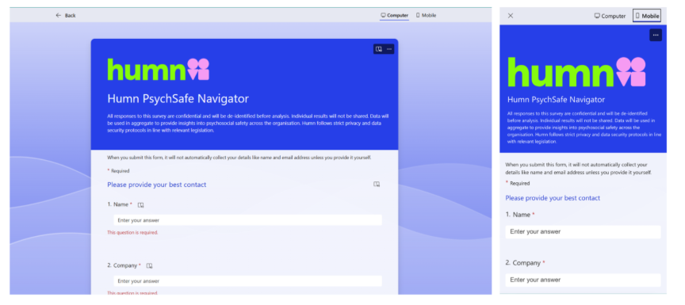
Figure 7: PsychSafe Navigator Form interface for desktop and mobile versions
In the case of TBRA worksheet, the semantics to the field and logic path logic was demonstrated using a manual, static configuration, and manual scoring, before introducing automation. The information was sparse on purpose (predefined dropdowns and text areas) to allow seeing how users navigated through the sections and revised phrasing, sequence and density without being distracted by formula complexity.
On the back-end side, we have created tables of Respondents, Readiness Survey and TBRA entry with only the basic attributes (IDs, timestamps, status). To ease process of finalising the data contracts, initially the relationships were loose (GUID, not enforced lookups). At this phase, the responses that were received through the Survey in Microsoft Forms were stored in the Forms response store and were planned to be mapped and synchronised to the Dataverse schema in future prototypes.
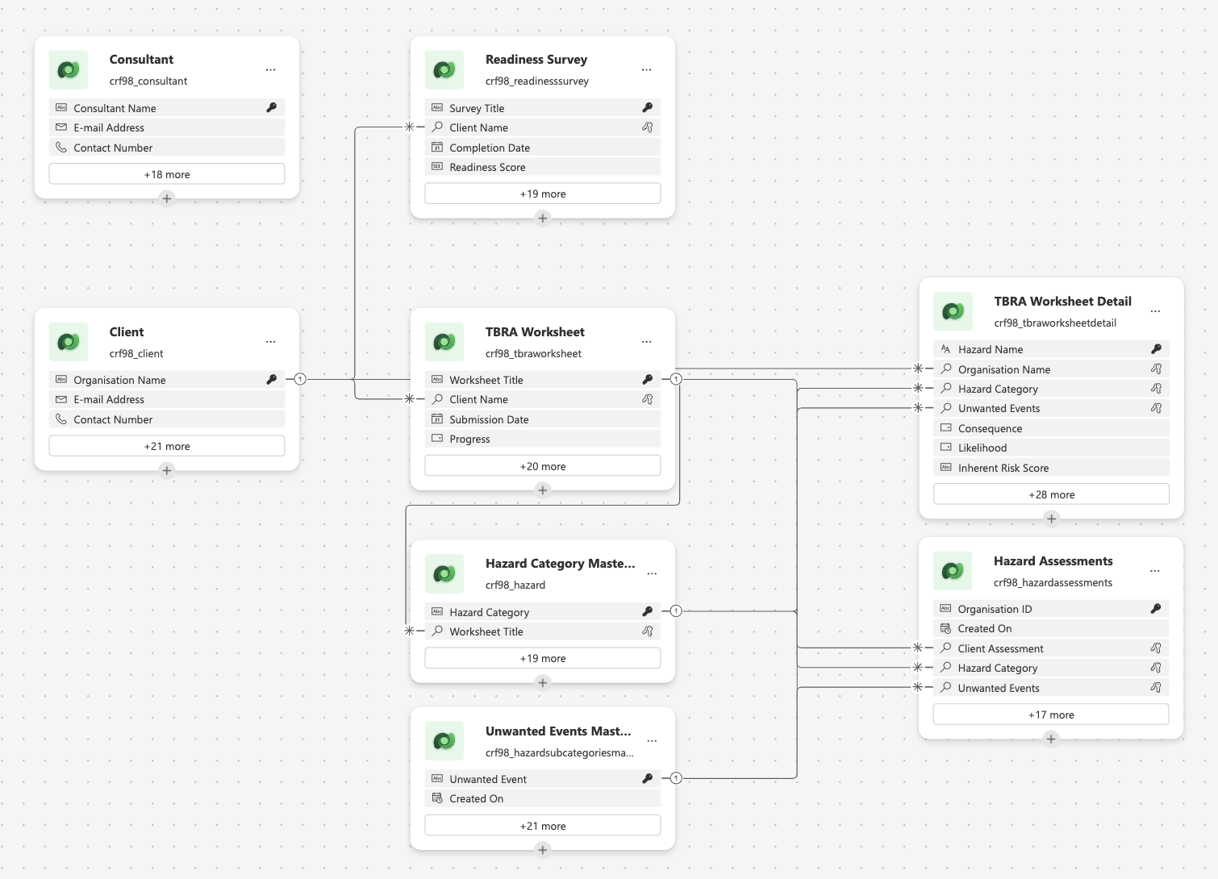
Figure 8: Data flows in Dataverse

4.2.2 Prototype v2 – Dataverse Integration and Conditional Logic
We advanced from static forms to a data-driven flow. On the front end, selecting a Hazard Category now filters the Unwanted Events dropdown to only relevant options, with conditional visibility keeping non-relevant sections hidden to reduce cognitive load. On the back end, we modelled HazardCategory and UnwantedEvent as Dataverse Choice/Lookup columns and stored Likelihood and Consequence as structured fields to support calculation.
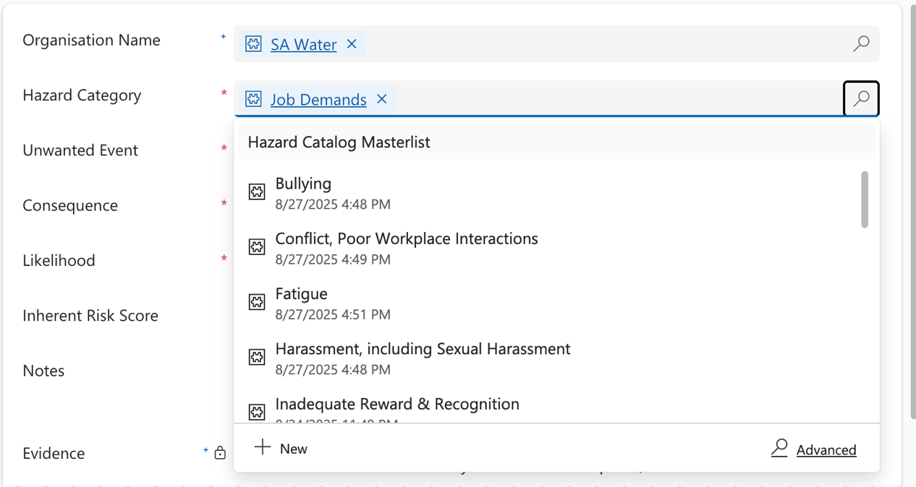
Figure 9: Dropdown function for Hazard Category
Using Dataverse business rules, the Inherent Risk Level is auto-calculated from the chosen Likelihood x Consequence and written back as the single source of truth. We pass the created record’s GUID via OnSuccess to maintain a clean audit trail. Early issues with delegation and branching complexity were mitigated by moving logic server-side, caching small reference lists in App.OnStart, and simplifying branches into mutually exclusive sections.
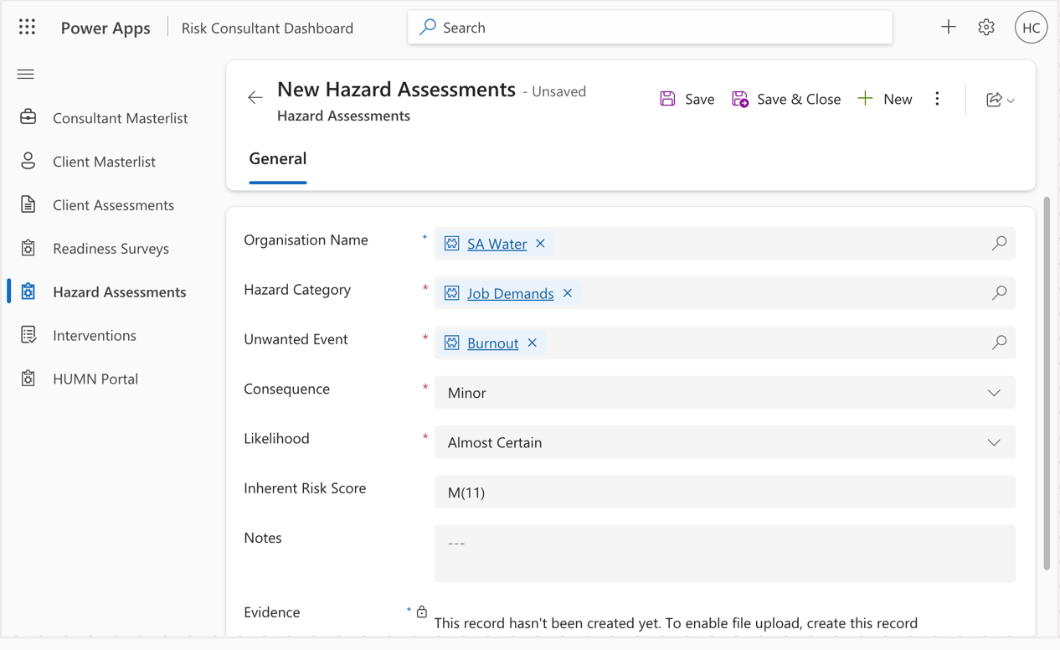
Figure 10: Auto-calculation for Inherent Risk Score based on Consequence x Likelihood

4.2.3 Prototype v3 – MVP Dashboard Mock, Login, Readiness Survey + Automation
We made the solution feel end-to-end. A SharePoint-based login portal now fronts the Canvas app: users are validated against a SharePoint Users list (username/password), and the app uses LookUp() on sign-in to set a cached user context, then routes them to the next task (TBRA worksheet, view status). Assessment records still persist to Dataverse. A static MVP dashboard mock shows the intended insights (recent submissions, “attention needed” items); live analytics were deferred to prioritise clean data capture and auditability.
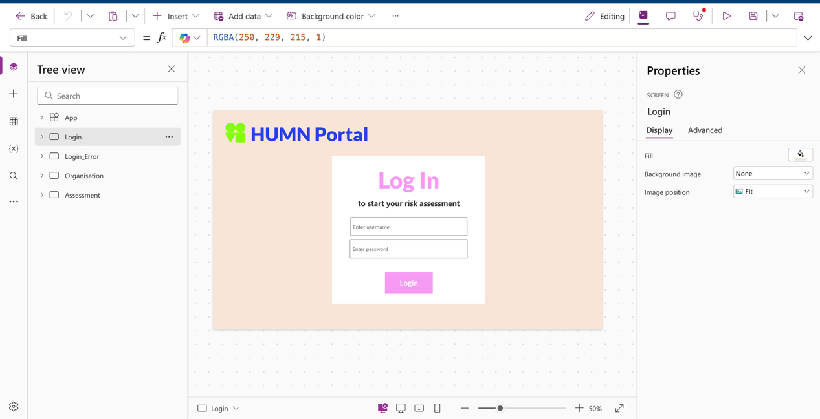
Figure 11: Login Screen for user portal
The 18-question PsychSafe Navigator submits responses to a Microsoft Excel workbook (stored in SharePoint) where built-in formulas compute the readiness score and level. A Power Automate flow then reads those computed valued and writes them to Dataverse. If the score meets the pass threshold, the flow sends a “Read for TBRA” email; otherwise, it emails tailored guidance.
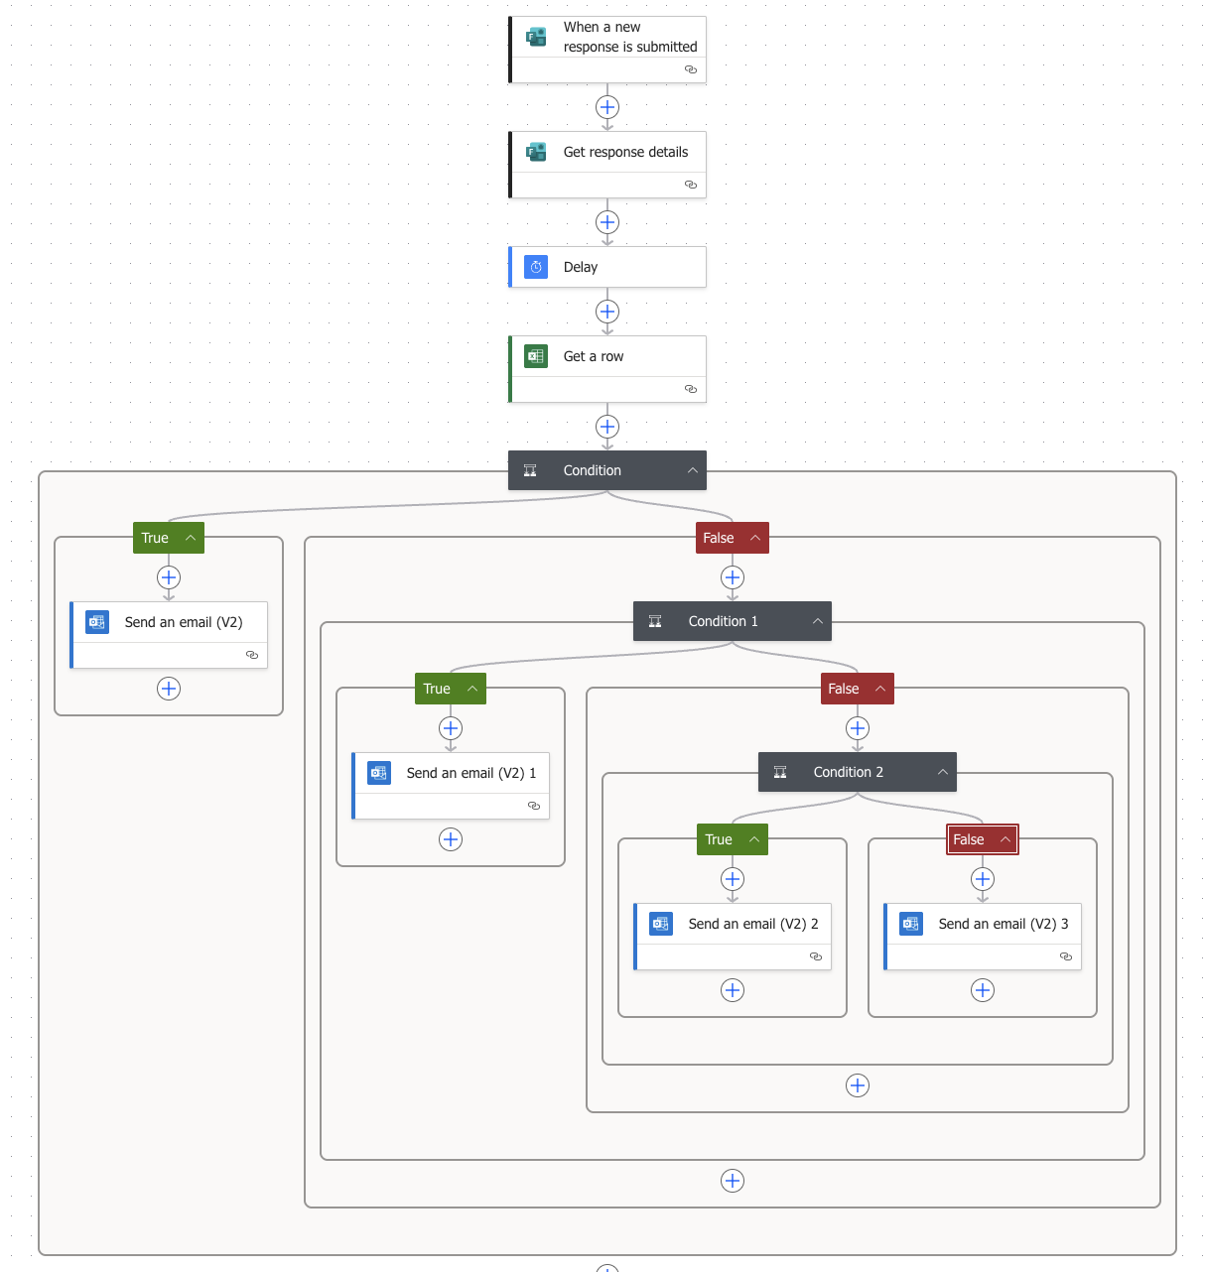
Figure 12: Automated PsychSafe Result & Recommendation Email Workflow
By automating this process, the workflow eliminates manual follow-up, reduces human error, and saves significant time for the Humn team. It ensures that every respondent receives accurate, consistent, and timely insights, enhancing customer experience and supporting continuous improvement toward ISO 45003 compliance.

4.2.4 Final MVP – Integrated Submission, Validation, and Secure Storage
The final MVP consolidated all modules into a coherent, auditable flow that a non-technical user could complete without guidance.
Validation was extended to pattern checks and dependency rules to enable users to fix the input at the time of entry as opposed to when required fields. We completed permissions and authentication of the dashboard and matched it with the Dataverse permissions, which is preparation of the future role-based access.
On the back end, the schema and relationships were locked; record creation updates wrote consistent timestamps, creator IDs, and status flags for traceability. The automation was used to complete the loop: When a positive readiness result was received, an email was sent to the user as a next step, which minimised follow-up.
We retained a small group of Dataverse calculated columns of canonical scoring along with enough metadata recorded in the record so that future analytics (e.g., risk factor breakdowns) would be supported.

4.2.5 Testing, Client Engagement, and What Improved Over Time
We ran weekly mentor reviews and scenario-based walkthroughs with clients that mimicked a real HR journey (Survey -> Email -> TBRA). Short, repeatable scripts (e.g., “complete a survey with X profile,” “trigger a ready email,” “submit a TBRA with Y hazards”) caught regressions each sprint.
External client testing was time-limited, so we used live demos for qualitative feedback on wording, section order, and TBRA cognitive load. That input drove the v3 usability pass: progressive disclosure, clearer labels, and inline summaries.
Compared with v2, the MVP shortened first-view forms, removed duplicates, and replaced static lists with governed dropdowns. Compared with v2, it eliminated false conditional paths and surface authoritative scores stored in Dataverse (rather than recomputing on the client).

5. Outcomes & Future Recommendations

5.1 Summary of Final Outcomes
Functionally, the prototype has achieved three (3) major outcomes. First, the digital Readiness Survey which allows Humn clients to self-assess their organisational maturity in psychosocial safety through a well-structured and scored questionnaire. Second, the TBRAWorksheet automated the evaluation of hazard likelihood and consequences through weighted logic and validated inputs. And thirdly, automated e-mail notifications and data synchronisation using Power Automate ensured seamless processing of information to the Dataverse. Collectively, these features have reduced manual processing times, minimised human error, and introduced real-time traceability for audit and reporting purposes.
Feedback from stakeholders confirmed during testing that the system will significantly improve efficiency and usability when compared with the previous Excel-based workflow. The introduction of structured data storage and validation logic ensured consistency in risk assessment records and facilitated better data-driven decision –making. In addition, the project successfully met the academic requirement of demonstrating a compliance-oriented solution under real-world constraints while maintaining industry relevance and technical precision.

5.2 Achievement of Organisational Benefits

5.2.1 Business Impacts
Developed within a closed academic environment with technical and licensing constraints, the HOTSA prototype served as a proof-of-concept for digitalising the certification workflow. If further developed and adopted, automating processes such as survey submission, data validation, and report generation could significantly streamline the certification cycle. Tasks that currently depend on manual formulas and email coordination could be completed in minutes, improving overall efficiency and potentially enabling Humn to manage a larger client base without increasing administrative workload.
The adoption of Microsoft Dataverse as a central repository introduced a single, authoritative source of data for all certification records. This eliminated version conflicts, enhanced auditability, and allowed instant retrieval for review and analysis. Built-in validation rules, pre-filled fields, and controlled dropdowns improved the consistency and reliability of data entry, strengthening confidence in risk assessments, and final reports.
Although Power BI dashboards were only partially implemented, they successfully demonstrated the feasibility of generating risk summaries and classification insights to support managerial decision-making. The solution’s design also aligned with psychosocial risk management standards, particularly ISO 45005:2021, reinforcing compliance readiness through automated recordkeeping and timestamping. More broadly, the project contributed to organisational learning by enhancing Humn’s internal capability in low-code development and data governance, laying out foundation for future digital transformation initiatives.

5.2.2 Client Impacts
For clients, HOTSA represents a significant improvement in the certification experience. The introduction of a digital interface enables real-time progress tracking, automatic notifications, and immediate feedback on assessment submissions. This transparency enhances client trust and engagement, reducing administrative uncertainty and delays associated with manual correspondence.
Furthermore, the structured digital process promotes greater consistency and fairness across assessments, improving the perceived reliability of certification outcomes. As Humn moves toward enterprise deployment, these client-facing benefits will translate into stronger relationships, improved service reputation, and a scalable compliance model aligned with regulatory expectations under SafeWork SA.

5.3 Limitations of Current Prototype
Despite its success, the HOTSA prototype was developed within a closed academic environment and was therefore subject to the time, scope, technical, and budget constraints typical of feasibility-phase projects. While the prototype demonstrated clear proof of concept, it remains an MVP that cannot yet be transferred to the client for operational use.
First, Power Apps formula limitations restricted complex risk matrix computations and multi-layered conditional logic. Advanced automation and scripting could not be implemented due to institutional permissions and the academic environment’s sandboxed setup. Secondly, Dataverse access and security configurations were simplified to align with academic licensing, meaning a full role-based access control model would require enterprise-grade provisioning.
Thirdly, although the Power BI dashboard was conceptually designed and mapped, time constraints prevented its full deployment. User testing was also limited to internal demonstrations within the university context; therefore, external client pilot testing will be essential to validate usability, data flow, and performance under real conditions. Lastly, the project intentionally focused on delivering the core MVP functionality, with integrations to external systems such as Microsoft Teams or SharePoint reserved for future iterations.
These factors do not detract from the project’s academic and technical value but rather frame it as a successful feasibility demonstration, establishing a strong foundation for future enterprise-level development.

5.4 Recommendations for Future Development
- Full CRM Integration: Future iterations should extend the prototype into a complete Customer Relationship Management system where readiness, assessment, and reporting modules are integrated with client records, billing, and workflow tracking.
- Enhanced Power BI Dashboards: Interactive visual dashboards should display real-time risk scores, trends, and compliance status to enable data-driven decision-making.
- Role-Based Access Control: Adopt Dataverse security roles and Azure Active Directory integration to segregate access between administrators, assessors, and clients.
- Advanced Automation and AI Integration: Leverage Power Automate Desktop and AI Builder for document classification, predictive analytics, and text summarization of evidence uploads.
- Comprehensive User Training Program: Implement training sessions and digital guides to build staff confidence in managing low-code platforms and data compliance.
- Security and Compliance Audit: Before production release, conduct penetration testing and a formal compliance assessment to ensure alignment with data protection laws.
- Continuous Improvement: Establish feedback loop with clients to iteratively refine user experience, ensuring the system remains responsive to evolving psychosocial safety regulations.

5.5 Scalability and Long-Term Adoption Considerations
For Humn to scale HOTSA beyond the prototype, strategic planning around infrastructure and governance is essential. The current system was developed within an academic sandbox—an isolated, restricted environment designed for proof-of-concept learning rather than operational deployment. To achieve production-grade scalability, Humn should transition from this academic environment to a dedicated Microsoft Power Platform production tenant with enterprise licensing, unlocking advanced integration, automation, and administrative controls.
Secondly, a structured data migration strategy should be implemented to consolidate existing Excel-based archives into Dataverse, incorporating data cleansing, validation, and standardised schemas to ensure accuracy and consistency. Thirdly, a comprehensive governance framework must be established to address data retention, privacy, access control, and auditability, key prerequisites for maintaining compliance at scale.
Scalability also depends on effective change management. Staff must be supported through targeted training, clear communication, and leadership reinforcement to adapt to new digital workflows. Embedding HOTSA within existing organisational policies will help institutionalize its use across teams. Finally, Humn should consider partnerships with regulatory agencies to align HOTSA’s data outputs with national compliance and reporting requirements under SafeWork SA.
By moving beyond the constraints of the controlled academic environment and embracing enterprise-grade infrastructure, Humn can ensure that HOTSA evolves from a successful prototype into a sustainable, industry-recognised compliance platform.

6. Reflection

6.1 Evaluation of Methodology and Approach
The hybrid methodological approach was not without challenges. Balancing creative exploration with time constraints required careful prioritisation each sprint. Documentation effort also increased because multiple frameworks demanded parallel tracking of research notes, process maps, and testing logs. Despite these pressures, the hybrid method provided a comprehensive lens through which to develop a solution that was both innovative and academically sound.

6.2 Key Challenges and Obstacles
Several technical and managerial obstacles arose throughout the project:
- Formula and Platform Limitations: Power Apps imposed constraints on complex lookup relationships and multi-step calculations. Workarounds required creative problem-solving and sometimes simplified logic to fit within system capabilities.
- Dataverse Permissions: The limited licensing environment restricted testing of multi-user access and record-level security. The required mock roles rather than full RBAC implementation.
- Schedule Compression: Overlapping academic and client deadlines led to intense sprint periods toward the end. The team had to re-prioritise features to be able to meet the delivery targets.
- Stakeholder Coordination: As external client representatives held senior roles, meeting availability was limited, requiring feedback and precise documentation of decisions.
Addressing these challenges enhanced the team’s resilience and collaboration skills, mirroring the adaptive behaviors expected in real-world consulting environments.

6.3 Lessons Learned
From a team perspective, the project reinforced several key lessons:
- Early Stakeholder Alignment is Critical. Clarifying expectations and technical boundaries at the start prevents misinterpretation and reduces re-work that may be needed.
- Iterative Testing Builds Quality. Testing small features early, such as validation logic and data submission, thus avoiding cascading errors later in development.
- Defined Roles Enhance Accountability. Clear allocation of design, technical, and documentation duties reduced duplication and strengthened team efficiency.
- Documentation Supports Continuity. Comprehensive records of meetings, decisions, and iterations ensured traceability for both academic assessment and client handover.
- Adaptability is a Core Competency. When technical barriers arose, the team rapidly shifted to alternative solutions like using simplified formulas or manual workarounds, without derailing project momentum.
These lessons underscore the importance of communication, structure, and flexibility in multi- stakeholder projects.

6.4 Personal Reflection on Skills Developed
Each team member reported significant professional growth through project experience. This project fostered both technical and interpersonal competencies aligned with consultancy and enterprise IT careers. The group members gained depth in requirements elicitation, stakeholder management, and UI/UX design within low-code frameworks, as well as enhanced skills in sprint coordination, risk management, and technical decision-making. And lastly, the group developed automation and data integration skills and became proficient in translating functional needs into system logic.
At a personal level, the project deepened understanding of how human-centered design and compliance principles intersect in real-world contexts. It also sharpened communication skills through formal presentations, report writing, and client demonstrations. Finally, the experience cultivated a stronger sense of professional identity as future IT consultants able to bridge technology and business outcomes through collaborative, ethical, and evidence-based practice.

7. Conclusion
Although time allocation was well planned, the team faced periods of schedule compression during the latter stages due to dependency between form logic and Dataverse schema setup. Nonetheless, through prioritisation and the Agile sprint method, the team managed to deliver all core MVP functionalities within the designated timeframe. The successful collaboration between Humn Pty Ltd and the UniSA student team enabled the alignment of academic objectives with real-world industry needs. External stakeholders provided subject-matter expertise and compliance oversight, while internal stakeholders within the student team managed project execution, coordination, and delivery.
Digital transformation is closely tied to compliance and ethical governance. By implementing automation through Microsoft Power Platform, the project integrates ISO/IEC 27001 principles of secure data handling with ISO 45003 guidelines for psychosocial risk prevention. Automated data collection, version control, and digital recordkeeping in Dataverse support transparency and auditability, while Power Automate’s governance features mitigate unauthorised access. This combination demonstrates how digital transformation can enhance both operational efficiency and regulatory integrity.
HOTSA represents a significant milestone in Humn Pty Ltd’s journey toward digital transformation and psychosocial safety compliance. The project addressed a clear organisational problem: manual, error-prone, and inefficient certification processes that hindered scalability and compliance alignment. Through a structured methodological framework combining Design Thinking, Double Diamond, and Agile, the team developed a low-code prototype that automated readiness surveys, hazard assessments, and reporting workflows using Microsoft Power Platform.
The outcomes demonstrate measurable improvements in efficiency, data accuracy, and transparency. Certification turnaround time was reduced, while automated validation and data capture ensured audit-ready records aligned with compliance standards. Beyond technical achievement, the project generated valuable organisational learning, building
Humn’s internal capability to manage digital systems, and fostering a culture of continuous improvement.
The project also provided academic and professional insight into how digital transformation can drive compliance and well-being in workplaces. It illustrated the integration of automation and human-centered governance, which showed that effective systems not only process data but also promote trust, safety, and accountability.
Future development should focus on full CRM integration, advanced analytics, and enterprise deployment supported by security audits and user training. With sustained investment, HOTSA can be a cornerstone of psychosocial safety certification, enhancing both compliance and employee well-being.
In conclusion, the project achieved its objective: to design a secure, efficient, and compliant prototype that bridges academic innovation with industry application. It stands as a model of how collaborative student-industry partnerships can produce real-world impact, demonstrating that low-code platforms can meaningfully advance both digital transformation and organisational resilience in the modern workplace.

8. References
Bolton, C., Machová, V., Kovacova, M., & Valaskova, K. (2018). The power of human–machine collaboration: Artificial intelligence, business automation, and the smart economy. Economics, Management, and Financial Markets, 13(4), 51–56. https://doi.org/10.22381/EMFM13420184
Bratincevic, J., & Koplowitz, R. (2021). The Forrester Wave™: Low-code development platforms for professional developers, Q2 2021 – The 14 providers that matter most and how they stack up. Forrester Research. https://lasvitprod.blob.core.windows.net/assets/2022/09/19/The-Forrester-Wave_-Low-Code-Development-Platforms-For-Professional-Developers-Q2-2021_uid_632864b699df4.pdf
Brown, T. (2009). Change by design: How design thinking transforms organizations and inspires innovation. Harper Business.
Carlgren, L., Rauth, I., & Elmquist, M. (2016). Framing design thinking: The concept in idea and enactment. Creativity and Innovation Management, 25(1), 38–57. https://doi.org/10.1111/caim.12153
Chow, T., & Cao, D.-B. (2008). A survey study of critical success factors in agile software projects. Journal of Systems and Software, 81(6), 961–971. https://doi.org/10.1016/j.jss.2007.08.020
Davenport, T. H., & Kirby, J. (2023). Managing business automation: Best practices and emerging trends. MIT Sloan Management Review, 64(2), 45–53.
Design Council. (2025). The double diamond. https://www.designcouncil.org.uk/our-resources/the-double-diamond/
Graf, M., Weiß, S., & Schünemann, M. (2025). Derivation of interventions in digitalised psychosocial risk assessment: Practical report and integration for counselling contexts. International Journal of Environmental Research and Public Health, 22(1), 112–128. https://doi.org/10.3390/ijerph22010112
Guthardt, T., Kosiol, J., & Hohlfeld, O. (2024, September). Low-code vs. the developer: An empirical study on the developer experience and efficiency of a no-code platform. In Proceedings of the ACM/IEEE 27th International Conference on Model Driven Engineering Languages and Systems (MODELS Companion ’24) (pp. 1–10). ACM. https://doi.org/10.1145/3652620.3688332
Hinterhuber, A., Vescovi, T., & Checchinato, F. (2024). Managing business automation and digital transformation: Designing for value and compliance. In Managing business automation and digital transformation (pp. 3–10). Routledge.
International Organization for Standardization. (2021). ISO 45003:2021 – Occupational health and safety management — Psychological health and safety at work — Guidelines for managing psychosocial risks. ISO. https://www.iso.org/standard/64283.html
International Organization for Standardization, & International Electrotechnical Commission. (2022). ISO/IEC 27001:2022 – Information security, cybersecurity and privacy protection — Information security management systems — Requirements. ISO. https://www.iso.org/standard/82875.html
Microsoft Corporation. (2023). A deep dive into Microsoft Power Automate. Apress. https://doi.org/10.1007/978-1-4842-9732-2
NewsRX Staff. (2023, February 22). Newgen recognized in 2023 Gartner® Magic Quadrant™ for enterprise low-code application platforms for third year in a row. Computer Weekly News, 293. Gale Business: Insights. https://link.gale.com/apps/doc/A737804311/GBIB?u=unisa
Norman, D. (2002). The design of everyday things. Basic Books.
Project Management Institute. (2017). Agile practice guide. Project Management Institute. https://www.pmi.org/standards/agile
Serrador, P., & Pinto, J. K. (2015). Does Agile work? A quantitative analysis of agile project success. International Journal of Project Management, 33(5), 1040–1051. https://doi.org/10.1016/j.ijproman.2015.01.006
Stickdorn, M., Hormess, M. E., Lawrence, A., & Schneider, J. (2018). This is service design doing. O’Reilly Media.

